**KAIXIANG HUANG**

**EDUCATION**

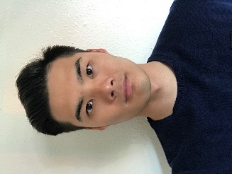**University of Illinois at Urbana-Champaign**

Champaign, IL

May 2017

*Bachelor of Science in Material Science and Engineering*

**University of Southern California**

Ongoing

*Master of Science in Engineering Management*

**EXPERIENCE**

**John Rogers’ Research Group at Materials Research Laboratory**

Champaign, IL

March 2016 – March 2017

***Group Member***

* Assist postdocs and Phds with research work in 3D assembly technology, performing photolithography and etching.
* Implement 3D transformation from 2D geometric pattern by placing the 2D pattern onto a pre-stretch elastomer and gradually release it.
* Edit images of 3D assembly process.

**Autoclub at the University of Illinois at Urbana-Champaign**

Champaign, IL

June 2015 – June 2016

***Consultant***

* Educated inexperienced car buyers on the ideal specifications needed for a car to satisfy their needs
* Arrange meetings with clients to access their automobile feature preference such as rearview camera, heated seat, lane-departure warning etc. to ensure their needs are being met
* Conduct database searches to identify car makes, models, and features that are consistent with customer requirement

**ACTIVITIES**

**Floor Lovers Illinois & Imagination Crew**

Champaign, IL

2013 – 2017

***Artistic Director and Active Member***

* Meet with club members weekly to foster an appreciation of breakdancing and bring like-minded people together
* Train new members and introduce our hip-hop community and spirit to them
* Plan more than 10 performances for on-campus events with more than 800 audiences

**International Volunteer HQ**

Kathmandu, Nepal

June – Aug 2013

***Volunteer***

* Took care of orphans from 4 to 12 years old
* Prepared daily meals and prayed with kids together at night
* Taught elementary Math, English and basic dancing
* Organized recreational sporting activities to promote physical and mental wellness

**SKILLS                                                                                                                                       Computer:** Excel, MS Project, Pyhton, R, MATLAB, SPSS, Origin, Java, Solidworks

**Languages:** Fluent in English, Cantonese and Mandarin